**Day 24**

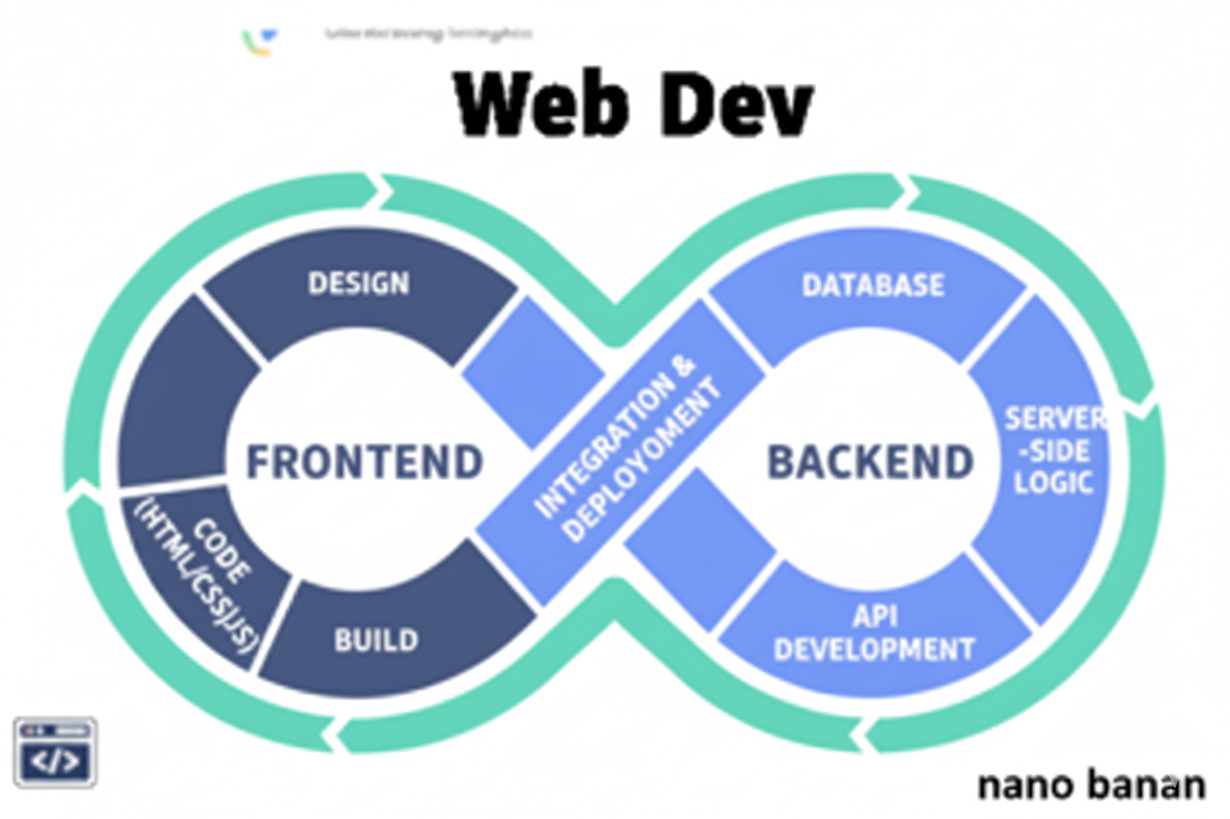

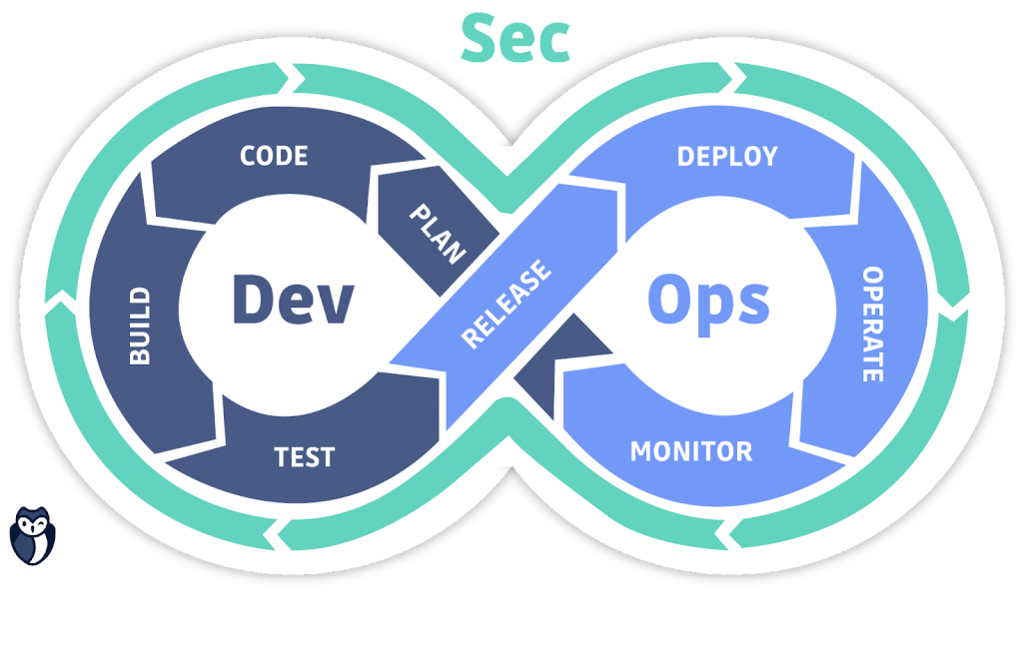

**“Web Development + Security”**

**CSS Float and Clear:**

**What is Float in CSS?**

The float property is used to move an element to the left or right of its container, allowing other elements (like text or images) to wrap around it.

**Common values of float:**

* left → floats the element to the left side.
* right → floats the element to the right side.
* none → default, element stays in normal flow.
* inherit → takes the float value from its parent.

**What is Clear in CSS?**

The clear property tells an element not to wrap around floating elements — it “clears” the float.

**Common values of clear:**

* left → no floating elements allowed on the left.
* right → no floating elements allowed on the right.
* both → no floating elements on either side.
* none → default, allows floats on both sides.

To understand this concept, we first need to create this:

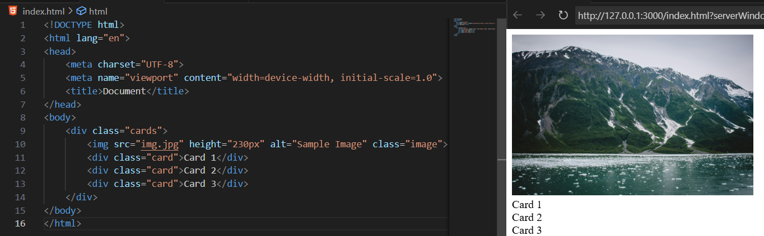

Let’s change the content of Card1 to a para: clearly the para came below the image.

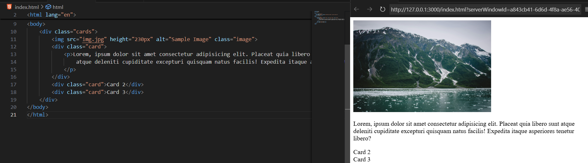

Now, what if we want that the content of para & other text to be at right of the image, then for that we will change the property of image to float:left, as shown below:

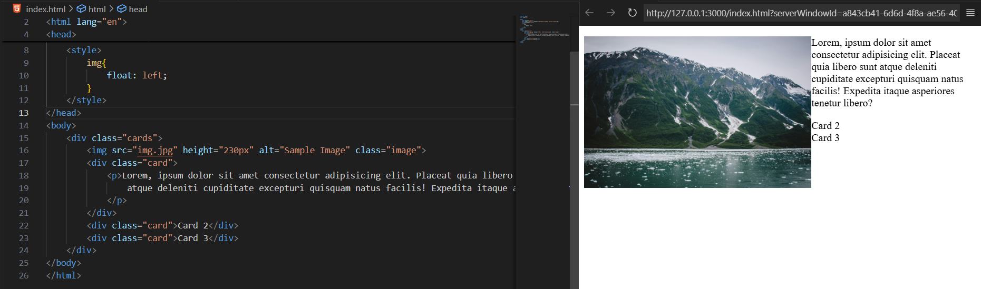

Now, let’s add some borders to the div:

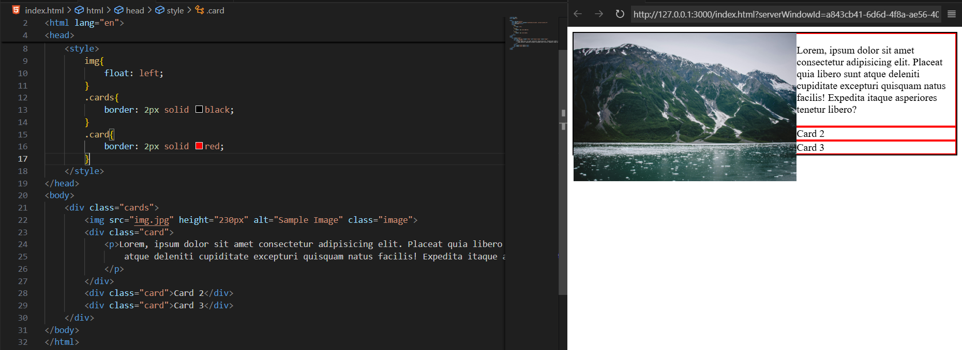

We can clearly see the issue, the image is overflowing from the container box, so we need to make sure that it doesn’t do so, for which we will use the property, display: flow-root with the parent container, as shown below:

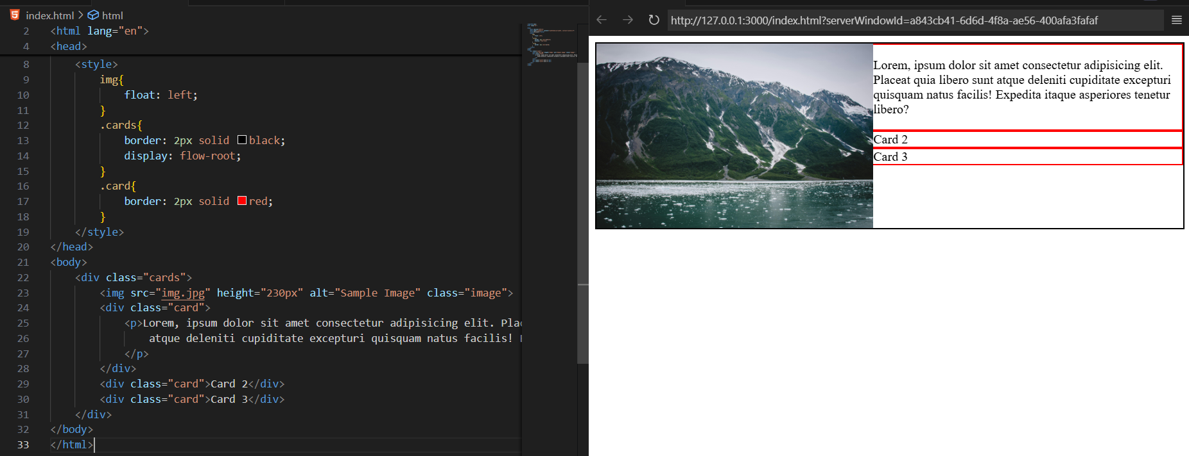

In case we want the float:right, then below example:

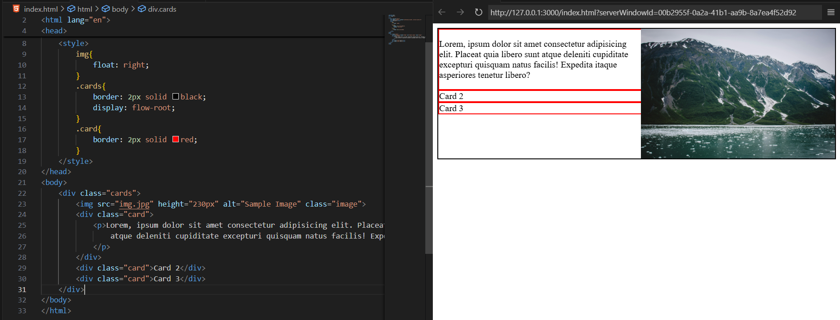

Now, what will happen if the para inside the <div> whose class is card is very big? Then the text will adjust as per the image. As shown below:

Code:

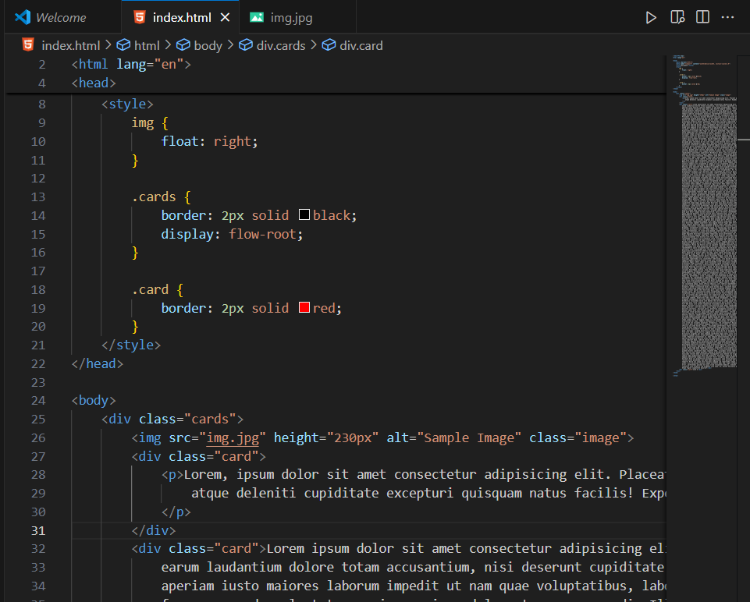

Output:

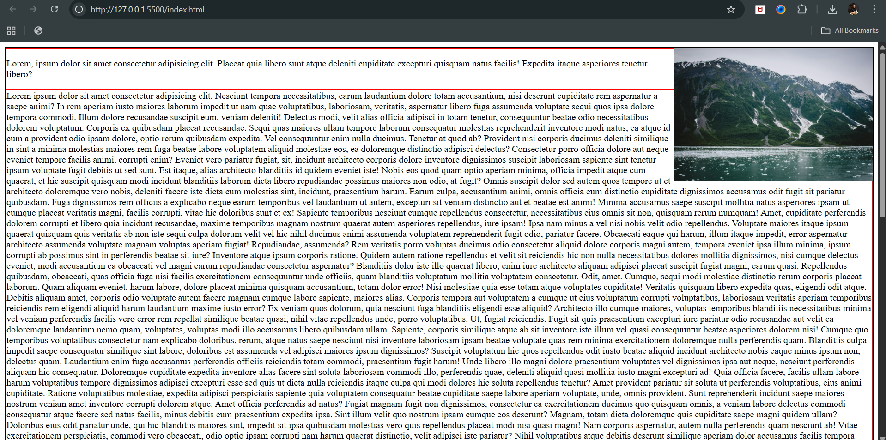

Now, suppose we want that the Card 2 whose class is card2 (we updated it now), don’t allow any element to be on its right, then we will use the property clear:right, as shown below:  
Code:

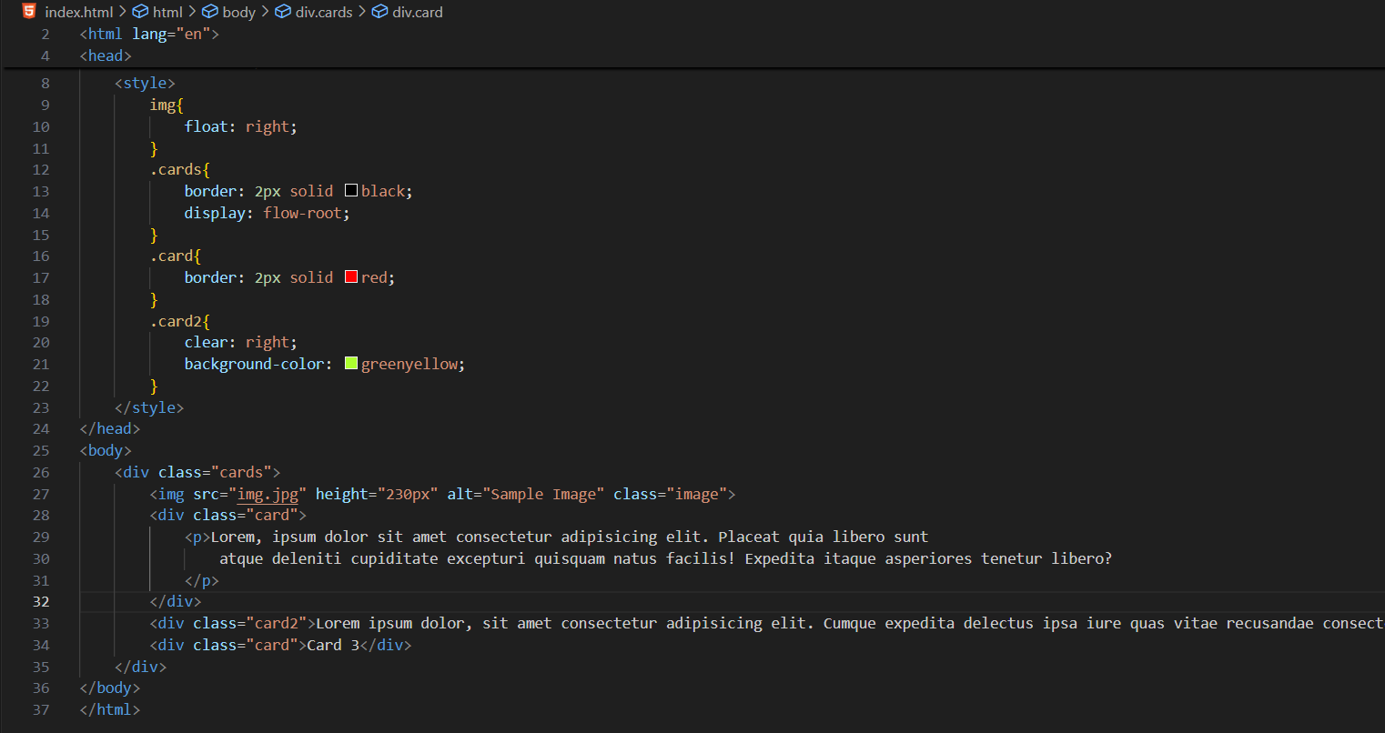

Output:

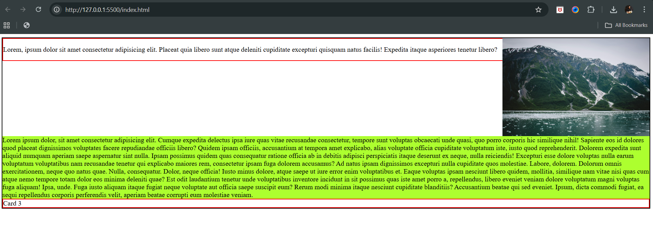

Tips:

| **Practice** | **Reason** |
| --- | --- |
| Use float mainly for images | Keeps text wrapping simple |
| Clear floats properly | Prevents container collapse |
| Prefer Flexbox/Grid for layout | More control and responsive |
| Use margins for spacing | Avoid text overlapping floated elements |
| Keep HTML semantic | Accessibility + maintainability |

--The End--